Many of you have either heard or read the Story of the Starfish. It’s a wonderful illustration of why we at Allied Women’s Center continue to do what we do, against the odds, every day to save as many babies as we can from death by abortion.

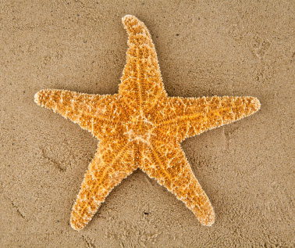
A young girl was walking along a beach upon which thousands of starfish had been washed up during a terrible storm. When she came to each starfish, she would pick it u and throw it back into the ocean. People watched her with amusement.

She had been doing this for some time when a man approached her and said, “Little girl, why are you doing this? Look at this beach! You can’t save all these starfish. You can’t begin to make a difference!”

The girl seemed crushed, suddenly deflated. But after a few moments, she bent down, picked up another starfish, and hurled it as far as she could into the ocean. Then she looked up at the man and replied, “Well, I made a difference to that one!”

The old man looked at the girl inquisitively and thought about what she had done and said. Inspired, he joined the little girl in throwing starfish back into the sea. Soon others joined, and all the starfish were saved.

— Adapted from The Star Thrower by Loren C. Eiseley

Sometimes a simple story is a great reminder of the difference one person can make. One person can be contagious and bring about change. So, when you’re confronted with a thousand Starfish in front of you, just bend over, pick one up, and put it back in the water. You’ll make a difference, one Starfish at a time.

